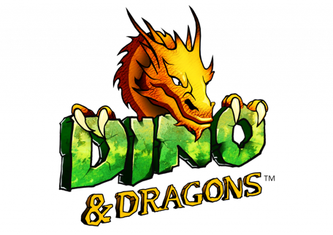

Dinosaurs & Dragons are invading New Port Richey
It’s the biggest thing to hit The Tampa Bay area in over 65 million years!

Contact: Diane Jones, 727-992-6928, diane@djpublicrelations.com

If you’ve ever wanted to get up close and personal with a T-Rex, triceratops, or long neck dinosaur, or check out the wingspan on a dragon, then you should look no further than the Dinos & Dragons exhibit opening December 9th in New Port Richey, Florida.

Nearly 100 life-size dinosaurs, along with a few dragons, are taking over the small town of New Port Richey and the field at the Harry Schwettman Education Center near Downtown, in the upcoming exhibit – an event 65 million years in the making.

With the largest creatures among shows of this kind, the event promises some dinos and dragons that stand three stories tall and are 60 feet long. Dino & Dragons is an international traveling exhibit that has never been seen east of Mississippi. Think Jurassic Park with an educational twist. Why New Port Richey? Because of the Museum of Archeology, Paleontology and Science (MAPs), a nonprofit natural history museum located in New Port Richey...and also one of Pasco County’s best kept secrets. MAPS is the only Natural History Museum in the Tampa Bay area.

Dino & Dragons is an interactive and educational experience that consists of nearly 100 life-size dinosaurs, dragons, hands-on labs, shows, rides and more. It is a family-friendly, stroll-at-your-own-pace experience. Visitors will walk through the Dinosaur Land and Mystical World to experience what the earth was like 65 million years ago when the dinosaur race still occupied the planet. Roving dinosaurs and dino petting will also take place on your journey.

Other show highlights include a Triceratops laying eggs (and you get to keep the egg!), a battle of wits with the dangerous Velociraptors, and a dinosaur-infested maze where visitors are on a mission to find the key card necessary to escape.

Dino & Dragons details are as follows:
- December 9, 2022 – Feb. 6, 2023
- Open 6 days a week – closed on Mondays
- Times will vary depending on dates.
- Tickets are date and time specific, and in order to ensure a pleasant experience for everyone, daily capacity will be limited.
- Schwettman Education Center, 5520 Grand Blvd., New Port Richey, 34652

Tickets start at $20 and are only available to purchase online and in advance.
For more information about this exhibit, visit www.dinoanddragonsnpr.com.

